**Tours/Travels**

**PES2UG21CS025-Adhi Nandan J**

**PES2UG21CS052-Akshit Pandharkar**

**PES2UG21CS199-Hemanth M**

**Abstract**

Tourism is a major economic activity that has developed significantly over the years.

Many travel agencies are available to the tourists to select the customised packages according to their wish. This program will be working on the same agenda, helping tourists selecting the package their comfortable with.

This is a code is written in Python language. First the user gets started with a registration process where he/she is asked to fill in some details as per the sample displayed. The registration is done in a tkinter window that has some basic graphical elements designed in it.

Once the registration is done a list of five places that is the places available for travel are displayed to the user using stacks.

Our travel agency offers packages to Ooty, Goa, Wayanad, Hyderabad and Pune. The user will have to choose the index number corresponding to the place he/she wishes to go.

The chosen index will be popped and displayed using basic stack operations.

After choosing the place the user can confirm it by allowing to display a itinerary including overview and highlights of the place. This is again displayed on a tkinter window using the text widget from tkinter.

A day-wise itinerary follows describing the tour details in a sequential manner. We have used file handling to display the day-wise itinerary.

A graph showing average visits to the place in a monthly fashion throughout the year is displayed.

We have used pyplot to design the graph. Once this is done the packages available to the place chosen are shown using simple programming.

This code offers three set of packages for a particular place namely basic, semi-deluxe and deluxe. These packages provide a detail of the bus type, food and accommodation sorted budget wise.

After the packages are displayed the user can proceed by entering the index number following the package, he/she has chosen. Two notes displaying the difference in pricing for age less than and above twelve follows.

The user has to enter the number of people travelling both age below and above twelve.

The prices are inclusive of tax, the price of age less than twelve is half that of the adult. A voucher is offered for discount. This is done in a similar way as a lottery wherein if the user enters the same number as chosen by the computer, the user will be getting a discount of 10%.

Here we have used the random module to generate a random number between ten and twenty as the value chosen by the computer.

Coming to the last part about payment, we offer E-transfer method where the user enters the final amount to be paid according to the bill displayed and the money would automatically get transferred to our bank account with the registered phone number of the user.

**Table of contents**

|  |  |  |
| --- | --- | --- |
| Serial Number | Content | Page Number |
| 1. | Introduction | 4 |
| 2. | Design/Implementaion | 5-35 |
| 3. | Testing | 36 |
| 4. | Result and Analysis | 37-41 |
| 5. | Conclusion and Future Enhancments | 42 |
| 6. | References | 43 |

**Introduction**

Tourism is a major economic activity that has developed significantly over the years. It's one of the fastest-growing industry in the world that has changed the scenario of the world.

Many travel agencies are available to the tourists to select the customised packages according to their wish. This program will be working on the same agenda, helping tourists selecting the package their comfortable with.

This method of booking a tour online helps in saving time as you need not go to a travel agency and book the tour instead book and pay online for the tour. We have covered all the concepts taught to us and have designed this program. Hope it helps you and your friends in booking the perfect vacation.

**Design/Implementation**

from tkinter import*

import random

print("\t\tWelcome to BlueStar Tours and Travels\n")

print("Fill in the registration details to get started\n")

print("Here is a display of sample registration")

print("\tFull Name: Ram B")

print("\tDate of Birth: 12/11/19** ")

print("\tPhone Number: 99******12")

print("\tEmail: abc123@gmail.com\n")

print("Kindly adhere to the sample registration order for convenience")

root = Tk()

root.geometry('500x500')

root.title("WELCOME TO BLUESTAR TRAVELS")

root.configure(background="yellow")

#using GUI(tkinter)for the registration

label = Label(root, text="REGISTRATION ",width=20,bg="black",fg="white",font=("calibri", 20))

label.place(x=90,y=50)

label1 = Label(root, text="Full Name",width=20,font=("arial", 10))#creating labels

label1.place(x=80,y=130)

entry1 =Entry(root)

entry1.place(x=250,y=130)

label2 = Label(root, text="Date of Birth",width=20,font=("arial", 10))

label2.place(x=80,y=180)

entry2 = Entry(root)

entry2.place(x=250,y=180)

label3 = Label(root, text="Phone Number",width=20,font=("arial", 10))

label3.place(x=80,y=230)

entry3=Entry(root)

entry3.place(x=250,y=230)

label4 = Label(root, text="Email",width=20,font=("arial", 10))

label4.place(x=80,y=280)

entry4 = Entry(root)

entry4.place(x=250,y=280)

Button(root, text='Proceed',width=20,bg='grey',fg='white').place(x=180,y=350)#creating a button

root.mainloop()

print("\nYou have successfully registered with BlueStar travels !!!\n")

print("The available places for tour are:")

bill=0

discount=0

#using Data Structure(Stacks)to display the available places

def stk():

stack=[]

stack.append("1.Ooty")

stack.append("2.Goa")

stack.append("3.Wayanad")

stack.append("4.Hyderabad")

stack.append("5.Pune")

print(stack)

i=int(input("Enter the index number correspoding to the place you would like to go : "))

for j in range(1,6):

if j==i:

print("The destination you have choosen is")

print(stack.pop(j-1)) #using pop to display the destination choosen

print("The following places are also available")

print(stack)

stk()

while True: #using conditional statements(while loop)

ch=int(input("\nEnter the corresponding serial number to know more information about the tour: "))

if ch==1:

import tkinter as tk #using tkinter to display ooty itinerary in the tkinter window

root1=tk.Tk()

root1.geometry("1500x2500")

root1.title("ooty itinerary")

root1.configure(background="grey")

T = tk.Text(root1, height=80, width=150,bg="black",fg="white",font=("calibri", 14))

T.place(x=0,y=0)

quote = """OOTY:

*Overview:

Udagamandalam or ootacamund pr ooty is located in the heart of Nilgiris and often

known as 'Queen of hill stations'.It is a popular hill station in South India.

It ahs been a hideouy from scorching summer from the British days,infact it was the summer capital of the British.

*Highlights

-Botanical Garden

-Doddabetta Park

-tea Museum and Tea factory

-Rose Garden

-Ooty Lake

-Avalanche Lake

-Pykara Lake and Waterfall

-Toy train."""

T.insert(tk.END, quote)

tk.mainloop()

OOTY=open("Ootypro.txt","r") #using file handling to import and display daywise itinerary for ooty

OP=OOTY.read()

print(OP)

import numpy as np #using pyplot to display stats of ooty tourism

import matplotlib.pyplot as pl

x=['jan','feb','mar','apr','may','jun','jul','aug','sep','oct','nov','dec']

y=[1200,1321,1434,2422,2511,2532,1145,1254,1811,1743,1533,1211]

pl.xlabel("months")

pl.ylabel("average visitors")

pl.bar(x,y,width=0.3,color='b')

pl.show()

print("\nThese are the different categories avalable")

print("\nChoose your preferred category by entering the respective serial number")

cp=int(input("1.Basic\n2.Semi-Deluxe\n3.Deluxe\n"))

while True:

if cp==1:

print("NOTE 1:Price per head is the price only for 1 day including tax")

print("NOTE 2:Price for passengers of age below 12 will be charged only half of the original price")

print("\nPrice per head for age 12 and above:Rs. 1900")

print("Price per head for age below 12:Rs. 950")

maj1=int(input("\nNumber of people aged 12 and above:"))

min1=int(input("Number of people aged below 12:"))

bill=4*((maj1*1900)+(min1*950))

print("\n\nWe offer a lucky lottery type of discount for our customers")

print("The program would generate a random number from 10 to 20 and if you guess it right, there would be a discount of 10% on the final amount")

lottery=int(input("Choose a number from 10 to 20:"))

d=random.randint(10,20) #using random module

print("The number generated by the program is:",d)

print("Price for one day(inc tax):",bill/4)

print("Price for all dyas(inc ta)",bill)

if d==lottery: #calculating bill

discount=0.1*bill

bill=0.9*bill

print("Discount:",discount)

print("Final amount to be paid:",bill)

break

elif cp==2:

print("NOTE 1:Price per head is the price only for 1 day including tax")

print("NOTE 2:Price for passengers of age below 12 will be charged only half of the original price")

print("\nPrice per head for age 12 and above:Rs. 2100")

print("Price per head for age below 12:Rs. 1050")

maj1=int(input("\nNumber of people aged 12 and above:"))

min1=int(input("Number of people aged below 12:"))

bill=4*((maj1*2100)+(min1*1050))

print("\n\nWe offer a lucky lottery type of discount for our customers")

print("The program would generate a random number from 10 to 20 and if you guess it right, there would be a discount of 10% on the final amount")

lottery=int(input("Choose a number from 10 to 20:"))

d=random.randint(10,20)

print("The number generated by the program is:",d)

print("Price for one day(inc tax):",bill/4)

print("Price for all days(inc tax)",bill)

if d==lottery:

discount=0.1*bill

bill=0.9*bill

print("Discount:",discount)

print("Final amount to be paid:",bill)

break

elif cp==3:

print("NOTE 1:Price per head is the price only for 1 day including tax")

print("NOTE 2:Price for passengers of age below 12 will be charged only half of the original price")

print("\nPrice per head for age 12 and above:Rs. 2500")

print("Price per head for age below 12:Rs. 1250")

maj1=int(input("\nNumber of people aged 12 and above:"))

min1=int(input("Number of people aged below 12:"))

bill=4*((maj1*2500)+(min1*1250))

print("\n\nWe offer a lucky lottery type of discount for our customers")

print("The program would generate a random number from 10 to 20 and if you guess it right, there would be a discount of 10% on the final amount")

lottery=int(input("Choose a number from 10 to 20:"))

d=random.randint(10,20)

print("The number generated by the program is:",d)

print("Price for one day(inc tax):",bill/4)

print("Price for all days(inc tax)",bill)

if d==lottery:

discount=0.1*bill

bill=0.9*bill

print("Discount:",discount)

print("Final amount to be paid:",bill)

break

break

elif ch==2:

import tkinter as tk #using tkinter to display goa itinerary in the tkinter window

root1=tk.Tk()

root1.geometry('1500x2500')

root1.title("goa itinerary")

root1.configure(background="grey")

T = tk.Text(root1, height=80, width=150,bg="black",fg="white",font=("calibri", 14))

T.place(x=0,y=0)

quote = """GOA:

*Overview

Vacation is refreshment, a way to rejuvenate your senses. Goa is a must visit destination for this purpose.

This Indian state is a platform of utmost fun and an exciting vacation. Goa beaches are known for awesome scenic beauty and safe night life.

The luxurious villas at the beaches offer soothing Ayurveda massages, which have always been known for their extensive health benefits.

The Portuguese influence can still be found in the life style of the locals.

Some of the oldest churches of the country can be seen here, which are known for their invaluable inscriptions and unique architecture.

A land of spices and sea food, you can satisfy your taste buds with spicy prawn fries, quality wine and more.

Hence, plan 4 Days Goa Beaches Tour with us to make this vacation memorable.

*Highlights

-Basilica of BOM Jesus, Se-Cathedral

-Stroll Around Miramar Beach

-Enjoy Swimming at Baga Beach

-Take a Sun Bath at Colva Beach

-Enjoy boating on speedboats at Dona Paula."""

T.insert(tk.END, quote)

tk.mainloop()

GOA=open("Goapro.txt","r") #using file handling to import and display daywise itinerary for goa

GP=GOA.read()

print(GP)

import numpy as np #using pyplot to display stats of goa tourism

import matplotlib.pyplot as pl

x=['jan','feb','mar','apr','may','jun','jul','aug','sep','oct','nov','dec']

y=[1214,3012,1432,412,512,554,676,754,1813,1624,2554,1332]

pl.xlabel("months")

pl.ylabel("average visitors")

pl.bar(x,y,width=0.3,color='g')

pl.show()

print("\nThese are the different categories avalable")

print("Choose your preferred category by entering the respective serial number")

cp=int(input("1.Basic\n2.Semi-Deluxe\n3.Deluxe\n"))

while True:

if cp==1:

print("NOTE 1:Price per head is the price only for 1 day including tax")

print("NOTE 2:Price for passengers of age below 12 will be charged only half of the original price")

print("\nPrice per head for age 12 and above:Rs. 2100")

print("Price per head for age below 12:Rs. 1050")

maj1=int(input("\nNumber of people aged 12 and above:"))

min1=int(input("Number of people aged below 12:"))

bill=4*((maj1*2100)+(min1*1050))

print("\nWe offer a lucky lottery type of discount for our customers")

print("The program would generate a random number from 10 to 20 and if you guess it right, there would be a discount of 10% on the final amount")

lottery=int(input("Choose a number from 10 to 20"))

d=random.randint(10,20)

print("The number generated by the program is:",d)

print("Price for one day(inc tax):",bill/4)

print("Price for all dyas(inc ta)",bill)

if d==lottery:

discount=0.1*bill

bill=0.9*bill

print("Discount:",discount)

print("Final amount to be paid:",bill)

break

elif cp==2:

print("NOTE 1:Price per head is the price only for 1 day including tax")

print("NOTE 2:Price for passengers of age below 12 will be charged only half of the original price")

print("\nPrice per head for age 12 and above:Rs. 2300")

print("Price per head for age below 12:Rs. 1150")

maj1=int(input("\nNumber of people aged 12 and above:"))

min1=int(input("Number of people aged below 12:"))

bill=4*((maj1*2300)+(min1*1150))

print("\nWe offer a lucky lottery type of discount for our customers")

print("The program would generate a random number from 10 to 20 and if you guess it right, there would be a discount of 10% on the final amount")

lottery=int(input("Choose a number from 10 to 20"))

d=random.randint(10,20)

print("The number generated by the program is:",d)

print("Price for one day(inc tax):",bill/4)

print("Price for all dyas(inc ta)",bill)

if d==lottery:

discount=0.1*bill

bill=0.9*bill

print("Discount:",discount)

print("Final amount to be paid:",bill)

break

elif cp==3:

print("NOTE 1:Price per head is the price only for 1 day including tax")

print("NOTE 2:Price for passengers of age below 12 will be charged only half of the original price")

print("\nPrice per head for age 12 and above:Rs. 2700")

print("Price per head for age below 12:Rs. 1350")

maj1=int(input("\nNumber of people aged 12 and above:"))

min1=int(input("Number of people aged below 12:"))

bill=4*((maj1*2700)+(min1*1350))

print("\nWe offer a lucky lottery type of discount for our customers")

print("The program would generate a random number from 10 to 20 and if you guess it right, there would be a discount of 10% on the final amount")

lottery=int(input("Choose a number from 10 to 20"))

d=random.randint(10,20)

print("The number generated by the program is:",d)

print("Price for one day(inc tax):",bill/4)

print("Price for all dyas(inc ta)",bill)

if d==lottery:

discount=0.1*bill

bill=0.9*bill

print("Discount:",discount)

print("Final amount to be paid:",bill)

break

break

elif ch==3:

import tkinter as tk #using tkinter to display wayanad itinerary in the tkinter window

root1=tk.Tk()

root1.geometry('1500x2500')

root1.title("Wayanad itinerary")

root1.configure(background="grey")

T = tk.Text(root1, height=80, width=150,bg="black",fg="white",font=("calibri", 14))

T.place(x=0,y=0)

quote = """ WAYANAD:

*Overview:

Wayanad is a fascinating place, not just for nature-lovers but also for history-buffs.

Archeologists found traces of human civilization that have existed here for over 6000 years.

The Edakkal caves are the glowing evidence of the claim. However, there is not much of documented history of this region before the 18th century.

Wayanad has the largest tribal community in Kerala. Many of these tribal groups were treated as slaves by the landlords for a long time.

The historic Bonded Labor Act of 1976 made this unconstitutional. Now, most of these tribes make a living from their skills in agriculture,

carpentry, and craftsmanship. You can learn a lot about the tribes of Wayanad and their life in the Wayanad Heritage Museum.

Wayanad is surrounded by the Bandipur, Nagarhole and Mudumalai forests in the east. These three together with the eastern forests of Wayanad has

the largest tiger population in the whole world. While the whole district is covered in green,

if you love jungle safaris you should stay towards the east near the Muthanga hills.

The region Sultan Bathery in the interiors of Wayanad is famous for the Edakkal Caves and other heritage sites.

*Highlights:

-Banasura Sagara Dam

-Chembra Peak

-Sailing to Kuruva Island on a Bamboo Raft

-Kalpetta tea estate

-Phantom Rock

-Edakkal Caves

-Wayanad Heritage Museum

-Soochipara Falls

-Lakkidi viewpoint

-Wildlife tour in Wayanad."""

T.insert(tk.END, quote)

tk.mainloop()

WAY=open("Waypro.txt","r")#using file handling to import and display daywise itinerary for wayanad

WP=WAY.read()

print(WP)

import numpy as np #using pyplot to display stats of wayanad tourism

import matplotlib.pyplot as pl

x=['jan','feb','mar','apr','may','jun','jul','aug','sep','oct','nov','dec']

y=[1234,1332,1232,2412,1754,1033,621,732,1842,2665,2523,1365]

pl.xlabel("months")

pl.ylabel("average visitors")

pl.bar(x,y,width=0.3,color='y')

pl.show()

print("\nThese are the different categories avalable")

print("Choose your preferred category by entering the respective serial number")

cp=int(input("1.Basic\n2.Semi-Deluxe\n3.Deluxe\n"))

while True:

if cp==1:

print("NOTE 1:Price per head is the price only for 1 day including tax")

print("NOTE 2:Price for passengers of age below 12 will be charged only half of the original price")

print("\nPrice per head for age 12 and above:Rs. 1800")

print("Price per head for age below 12:Rs. 900")

maj1=int(input("\nNumber of people aged 12 and above:"))

min1=int(input("Number of people aged below 12:"))

bill=4*((maj1*1800)+(min1*900))

print("\nWe offer a lucky lottery type of discount for our customers")

print("The program would generate a random number from 10 to 20 and if you guess it right, there would be a discount of 10% on the final amount")

lottery=int(input("Choose a number from 10 to 20"))

d=random.randint(10,20)

print("The number generated by the program is:",d)

print("Price for one day(inc tax):",bill/4)

print("Price for all dyas(inc ta)",bill)

if d==lottery:

discount=0.1*bill

bill=0.9*bill

print("Discount:",discount)

print("Final amount to be paid:",bill)

break

elif cp==2:

print("NOTE 1:Price per head is the price only for 1 day including tax")

print("NOTE 2:Price for passengers of age below 12 will be charged only half of the original price")

print("\nPrice per head for age 12 and above:Rs. 2200")

print("Price per head for age below 12:Rs. 1100")

maj1=int(input("\nNumber of people aged 12 and above:"))

min1=int(input("Number of people aged below 12:"))

bill=4*((maj1*2200)+(min1*1100))

print("\nWe offer a lucky lottery type of discount for our customers")

print("The program would generate a random number from 10 to 20 and if you guess it right, there would be a discount of 10% on the final amount")

lottery=int(input("Choose a number from 10 to 20"))

d=random.randint(10,20)

print("The number generated by the program is:",d)

print("Price for one day(inc tax):",bill/4)

print("Price for all dyas(inc ta)",bill)

if d==lottery:

discount=0.1*bill

bill=0.9*bill

print("Discount:",discount)

print("Final amount to be paid:",bill)

break

elif cp==3:

print("NOTE 1:Price per head is the price only for 1 day including tax")

print("NOTE 2:Price for passengers of age below 12 will be charged only half of the original price")

print("\nPrice per head for age 12 and above:Rs. 2500")

print("Price per head for age below 12:Rs. 1250")

maj1=int(input("\nNumber of people aged 12 and above:"))

min1=int(input("Number of people aged below 12:"))

bill=4*((maj1*2500)+(min1*1250))

print("\nWe offer a lucky lottery type of discount for our customers")

print("The program would generate a random number from 10 to 20 and if you guess it right, there would be a discount of 10% on the final amount")

lottery=int(input("Choose a number from 10 to 20"))

d=random.randint(10,20)

print("The number generated by the program is:",d)

print("Price for one day(inc tax):",bill/4)

print("Price for all dyas(inc ta)",bill)

if d==lottery:

discount=0.1*bill

bill=0.9*bill

print("Discount:",discount)

print("Final amount to be paid:",bill)

break

break

elif ch==4:

import tkinter as tk #using tkinter to display hyderabad itinerary in the tkinter window

root1=tk.Tk()

root1.geometry('1500x2500')

root1.title("Hyderabad itinerary")

root1.configure(background="grey")

T = tk.Text(root1, height=80, width=150,bg="black",fg="white",font=("calibri", 14))

T.place(x=0,y=0)

quote = """HYDERABAD:

*Overview:

Hyderabad is the capital of southern India's Telangana state. A major center for the technology industry,

it's home to many upscale restaurants and shops. Its historic sites include Golconda Fort,

a former diamond-trading center that was once the Qutb Shahi dynastic capital.

The Charminar, a 16th-century mosque whose 4 arches support towering minarets, is an old city landmark near the long-standing Laad Bazaar.

*Highlights:

-Archival Museum.

-Birla Mandir.

-Birla Planetarium.

-Golconda Fort.

-Hyderabad Race Club.

-Lumbini Park.

-Mecca Masjid.

-Necklace Road. """

T.insert(tk.END, quote)

tk.mainloop()

HYD=open("Hydpro.txt","r")#using file handling to import and display daywise itinerary for hyderabad

HP=HYD.read()

print(HP)

import numpy as np #using pyplot to display stats of hyderabad tourism

import matplotlib.pyplot as pl

x=['jan','feb','mar','apr','may','jun','jul','aug','sep','oct','nov','dec']

y=[1123,1233,1455,2434,2254,521,654,987,1876,2666,2545,1022]

pl.xlabel("months")

pl.ylabel("average visitors")

pl.bar(x,y,width=0.3,color='r')

pl.show()

print("\nThese are the different categories avalable")

print("Choose your preferred category by entering the respective serial number")

cp=int(input("1.Basic\n2.Semi-Deluxe\n3.Deluxe\n"))

while True:

if cp==1:

print("NOTE 1:Price per head is the price only for 1 day including tax")

print("NOTE 2:Price for passengers of age below 12 will be charged only half of the original price")

print("\nPrice per head for age 12 and above:Rs. 2000")

print("Price per head for age below 12:Rs. 1000")

maj1=int(input("\nNumber of people aged 12 and above:"))

min1=int(input("Number of people aged below 12:"))

bill=4*((maj1*2000)+(min1*1000))

print("\nWe offer a lucky lottery type of discount for our customers")

print("The program would generate a random number from 10 to 20 and if you guess it right, there would be a discount of 10% on the final amount")

lottery=int(input("Choose a number from 10 to 20"))

d=random.randint(10,20)

print("The number generated by the program is:",d)

print("Price for one day(inc tax):",bill/4)

print("Price for all dyas(inc ta)",bill)

if d==lottery:

discount=0.1*bill

bill=0.9*bill

print("Discount:",discount)

print("Final amount to be paid:",bill)

break

elif cp==2:

print("NOTE 1:Price per head is the price only for 1 day including tax")

print("NOTE 2:Price for passengers of age below 12 will be charged only half of the original price")

print("\nPrice per head for age 12 and above:Rs. 2300")

print("Price per head for age below 12:Rs. 1150")

maj1=int(input("\nNumber of people aged 12 and above:"))

min1=int(input("Number of people aged below 12:"))

bill=4*((maj1*2300)+(min1*1150))

print("\nWe offer a lucky lottery type of discount for our customers")

print("The program would generate a random number from 10 to 20 and if you guess it right, there would be a discount of 10% on the final amount")

lottery=int(input("Choose a number from 10 to 20"))

d=random.randint(10,20)

print("The number generated by the program is:",d)

print("Price for one day(inc tax):",bill/4)

print("Price for all dyas(inc ta)",bill)

if d==lottery:

discount=0.1*bill

bill=0.9*bill

print("Discount:",discount)

print("Final amount to be paid:",bill)

break

elif cp==3:

print("NOTE 1:Price per head is the price only for 1 day including tax")

print("NOTE 2:Price for passengers of age below 12 will be charged only half of the original price")

print("\nPrice per head for age 12 and above:Rs. 2800")

print("Price per head for age below 12:Rs. 1400")

maj1=int(input("\nNumber of people aged 12 and above:"))

min1=int(input("Number of people aged below 12:"))

bill=4*((maj1*2800)+(min1*1400))

print("\nWe offer a lucky lottery type of discount for our customers")

print("The program would generate a random number from 10 to 20 and if you guess it right, there would be a discount of 10% on the final amount")

lottery=int(input("Choose a number from 10 to 20"))

d=random.randint(10,20)

print("The number generated by the program is:",d)

print("Price for one day(inc tax):",bill/4)

print("Price for all dyas(inc ta)",bill)

if d==lottery:

discount=0.1*bill

bill=0.9*bill

print("Discount:",discount)

print("Final amount to be paid:",bill)

break

break

elif ch==5:

import tkinter as tk #using tkinter to display pune itinerary in the tkinter window

root1=tk.Tk()

root1.geometry('1500x2500')

root1.title("pune itinerary")

root1.configure(background="grey")

T = tk.Text(root1, height=80, width=150,bg="black",fg="white",font=("calibri", 14))

T.place(x=0,y=0)

quote = """PUNE:

*Overview:

Pune is a sprawling city in the western Indian state of Maharashtra. It was once the base of the Peshwas (prime ministers) of the Maratha Empire,

which lasted from 1674 to 1818. It's known for the grand Aga Khan Palace, built in 1892 and now a memorial to Mahatma Gandhi,

whose ashes are preserved in the garden. The 8th-century Pataleshwar Cave Temple is dedicated to the Hindu god Shiva.

*Highlights:

-Sinhagad Fort

-Katraj Snake Park

-ISKON Temple

-Aga Khan Palace

-Shaniwar Wada

-Dagdusheth Halwai Temple

-Lal Mahal

-Pataleshwar Cave."""

T.insert(tk.END, quote)

tk.mainloop()

PUNE=open("Punepro.txt","r")#using file handling to import and display daywise itinerary for pune

PP=PUNE.read()

print(PP)

import numpy as np #using pyplot to display stats of pune tourism

import matplotlib.pyplot as pl

x=['jan','feb','mar','apr','may','jun','jul','aug','sep','oct','nov','dec']

y=[1623,1823,1134,1034,1145,1267,613,734,1856,2646,2556,1613]

pl.xlabel("months")

pl.ylabel("average visitors")

pl.bar(x,y,width=0.3,color='g')

pl.show()

print("\nThese are the different categories avalable")

print("Choose your preferred category by entering the respective serial number")

cp=int(input("1.Basic\n2.Semi-Deluxe\n3.Deluxe\n"))

while True:

if cp==1:

print("NOTE 1:Price per head is the price only for 1 day including tax")

print("NOTE 2:Price for passengers of age below 12 will be charged only half of the original price")

print("\nPrice per head for age 12 and above:Rs. 2400")

print("Price per head for age below 12:Rs. 1200")

maj1=int(input("\nNumber of people aged 12 and above:"))

min1=int(input("Number of people aged below 12:"))

bill=4*((maj1*2400)+(min1*1200))

print("\nWe offer a lucky lottery type of discount for our customers")

print("The program would generate a random number from 10 to 20 and if you guess it right, there would be a discount of 10% on the final amount")

lottery=int(input("Choose a number from 10 to 20"))

d=random.randint(10,20)

print("The number generated by the program is:",d)

print("Price for one day(inc tax):",bill/4)

print("Price for all dyas(inc ta)",bill)

if d==lottery:

discount=0.1*bill

bill=0.9*bill

print("Discount:",discount)

print("Final amount to be paid:",bill)

break

elif cp==2:

print("NOTE 1:Price per head is the price only for 1 day including tax")

print("NOTE 2:Price for passengers of age below 12 will be charged only half of the original price")

print("\nPrice per head for age 12 and above:Rs. 2700")

print("Price per head for age below 12:Rs. 1350")

maj1=int(input("\nNumber of people aged 12 and above:"))

min1=int(input("Number of people aged below 12:"))

bill=4*((maj1*2700)+(min1*1350))

print("\nWe offer a lucky lottery type of discount for our customers")

print("The program would generate a random number from 10 to 20 and if you guess it right, there would be a discount of 10% on the final amount")

lottery=int(input("Choose a number from 10 to 20"))

d=random.randint(10,20)

print("The number generated by the program is:",d)

print("Price for one day(inc tax):",bill/4)

print("Price for all dyas(inc ta)",bill)

if d==lottery:

discount=0.1*bill

bill=0.9*bill

print("Discount:",discount)

print("Final amount to be paid:",bill)

break

elif cp==3:

print("NOTE 1:Price per head is the price only for 1 day including tax")

print("NOTE 2:Price for passengers of age below 12 will be charged only half of the original price")

print("\nPrice per head for age 12 and above:Rs. 3100")

print("Price per head for age below 12:Rs. 1550")

maj1=int(input("\nNumber of people aged 12 and above:"))

min1=int(input("Number of people aged below 12:"))

bill=4*((maj1*3100)+(min1*1550))

print("\nWe offer a lucky lottery type of discount for our customers")

print("The program would generate a random number from 10 to 20 and if you guess it right, there would be a discount of 10% on the final amount")

lottery=int(input("Choose a number from 10 to 20"))

d=random.randint(10,20)

print("The number generated by the program is:",d)

print("Price for one day(inc tax):",bill/4)

print("Price for all dyas(inc ta)",bill)

if d==lottery:

discount=0.1*bill

bill=0.9*bill

print("Discount:",discount)

print("Final amount to be paid:",bill)

break

break

else:

print("Invalid please enter the right information")

print("\nFor more details or queries, contact Mr Hemanth at 9999999999/9090909090 who would be the guide for the tour")

print("\nWould you like to confirm the booking of the tour and go ahead with the online payment integrated within our site")

pay=input("Y for yes, N for no")

def abc(): #bill payment

if pay=='Y' or pay=='y':

print("\nYou would be transferring the amount and the site will have access to your bank account if you have registered with your phone number in the site")

while True:

paytm=int(input("Enter the amount to be paid"))

if paytm==bill:

print("Your payment of Rs.",paytm,"is successful")

break

else:

print("Please enter the right amount")

abc()

print("\nThank you for choosing Bluestar Tours and Travels\nHave a nice day\nYour tickets will be sent to your registered Email ID shortly.!!")

**Testing**

|  |  |  |
| --- | --- | --- |
| Commands | Input | Output |
| Input | Enter the index number corresponding to the place you would like to go | Printing destination and short itinerary |
| Packages | Enter the index no corresponding to the package you would like to choose | Goes to next step |
| No of people | Enter no of people above age 12 and below age 12 | Goes to next step |
| Lottery | Enter a no between 10 and 20 | If number matches, discount of 10% is applied to the bill, and calculates final amount to be paid |
| Payment | Enter amount displayed | If input is same as payment, payment successful and Thank You message is displayed  Else, the program will request you to pay the correct amount. |

**Result/ Analysis**

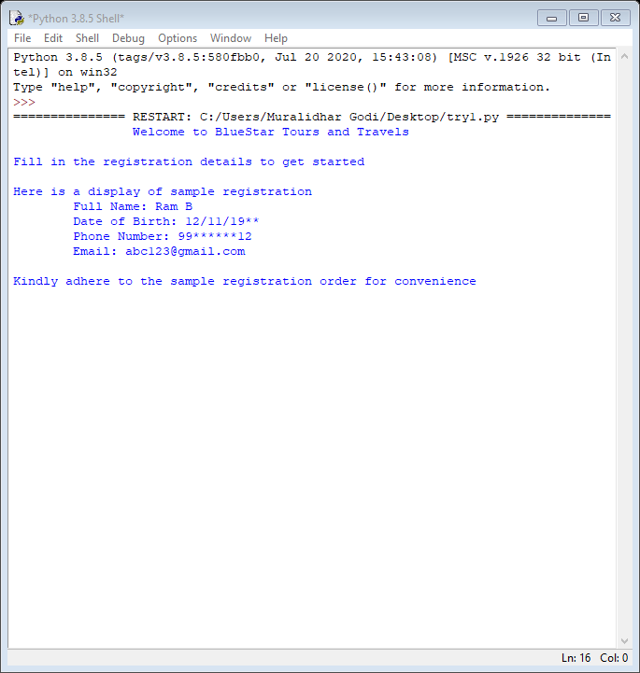

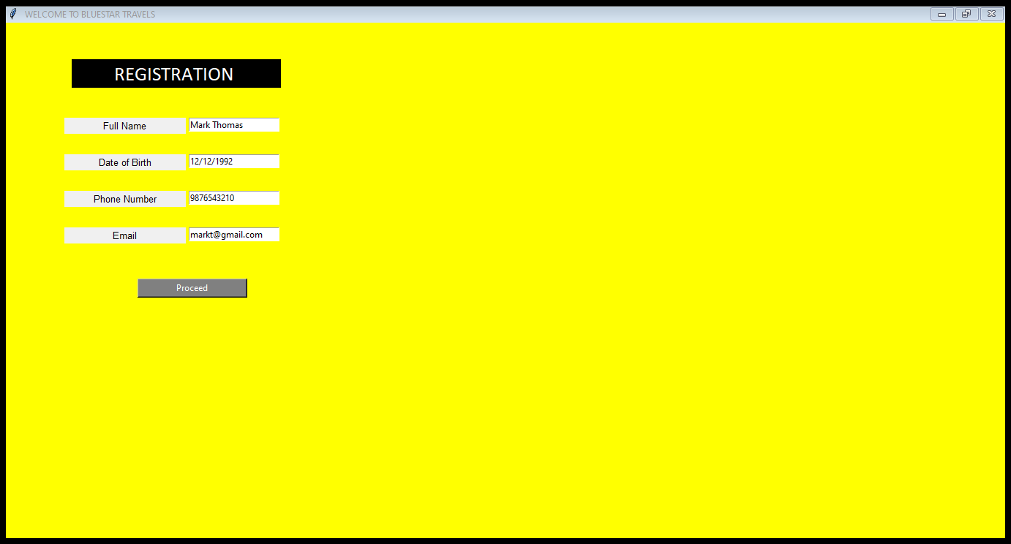Fig 1: Sample Registration format

Fig 2: Registration of the user

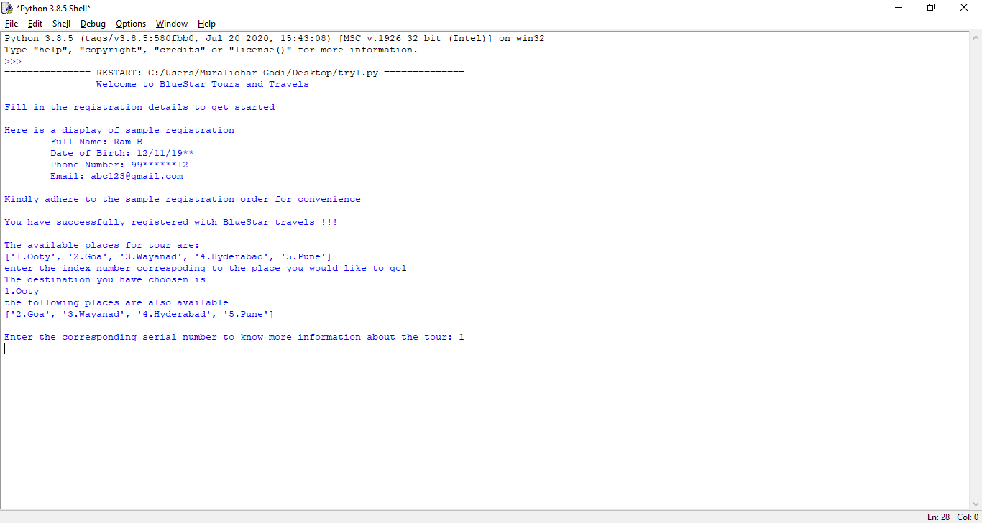

Fig 3: Selection of the tourist place

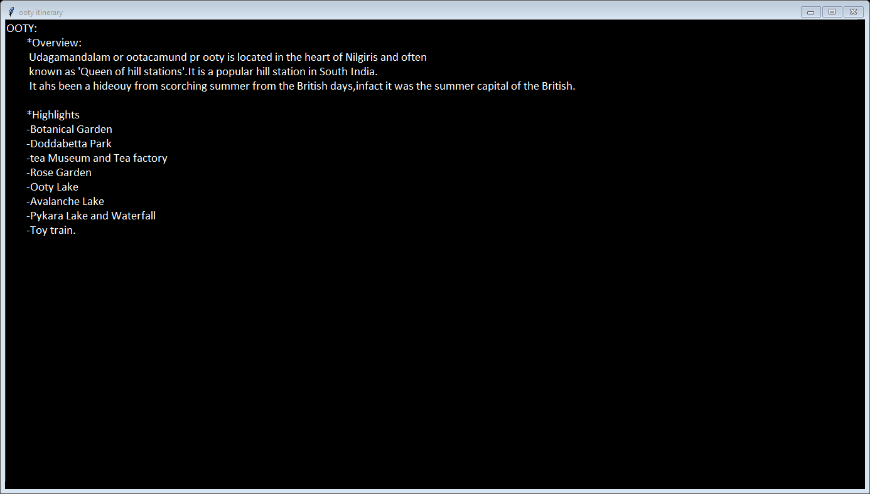

Fig 4.1: Overview and Highlights of the tour

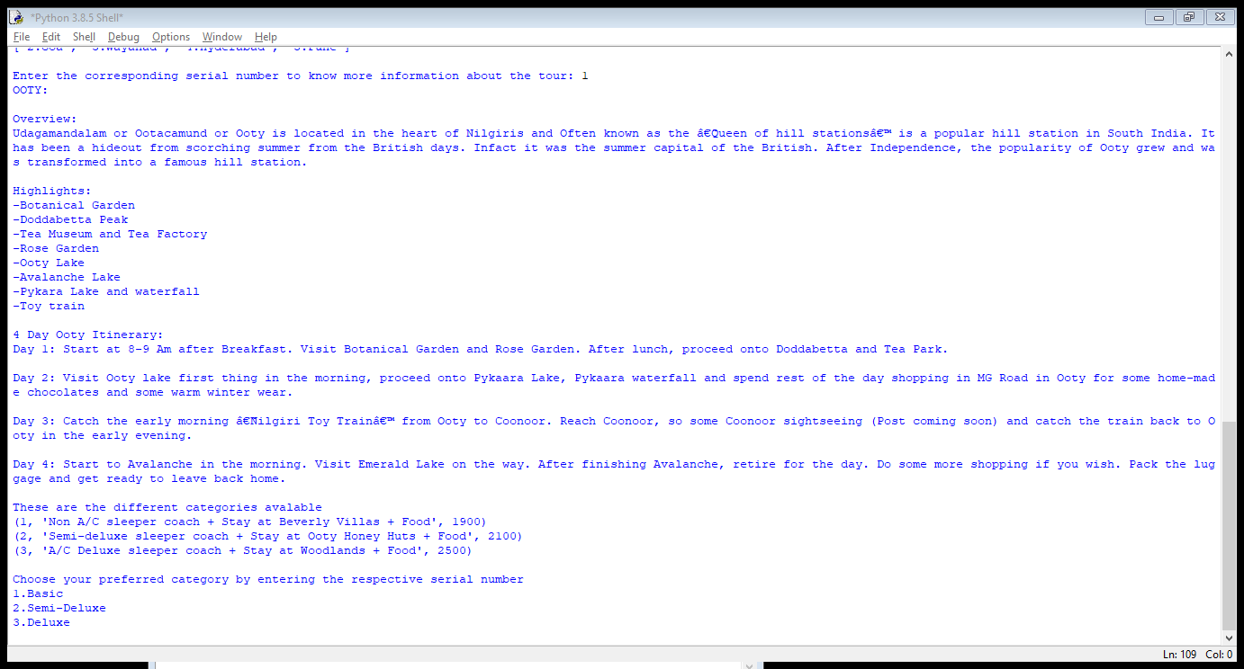

Fig 4.2: Tour Itinerary

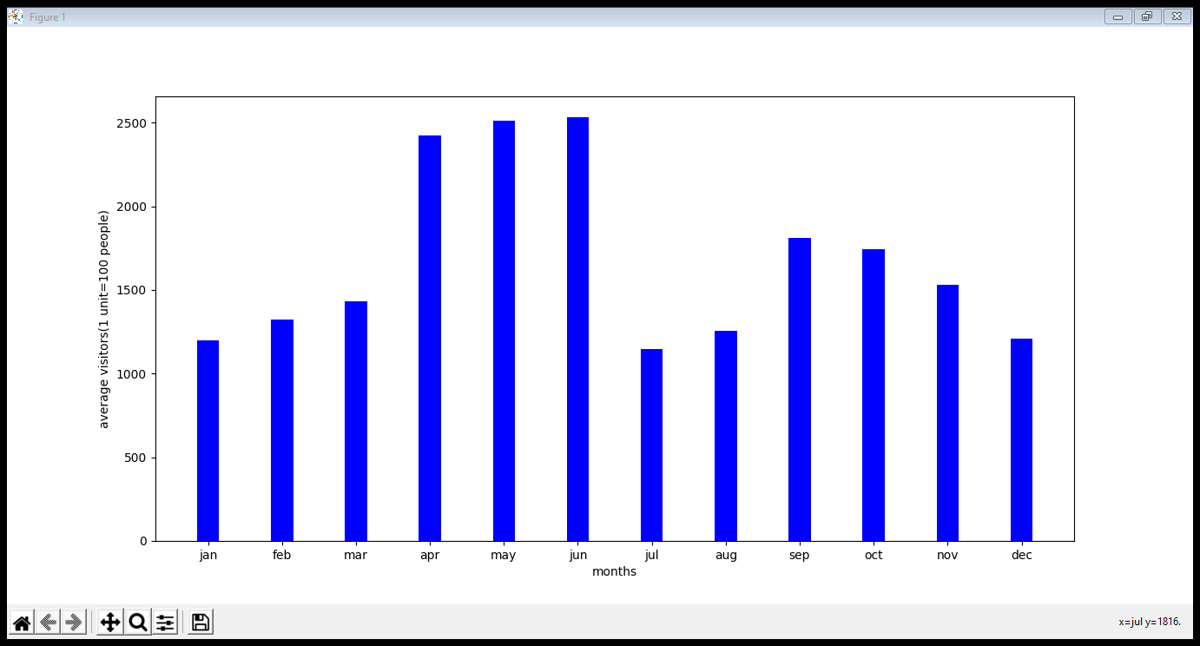

Fig 4.3: Bar chart depicting number of average visitors each month to the tourist place

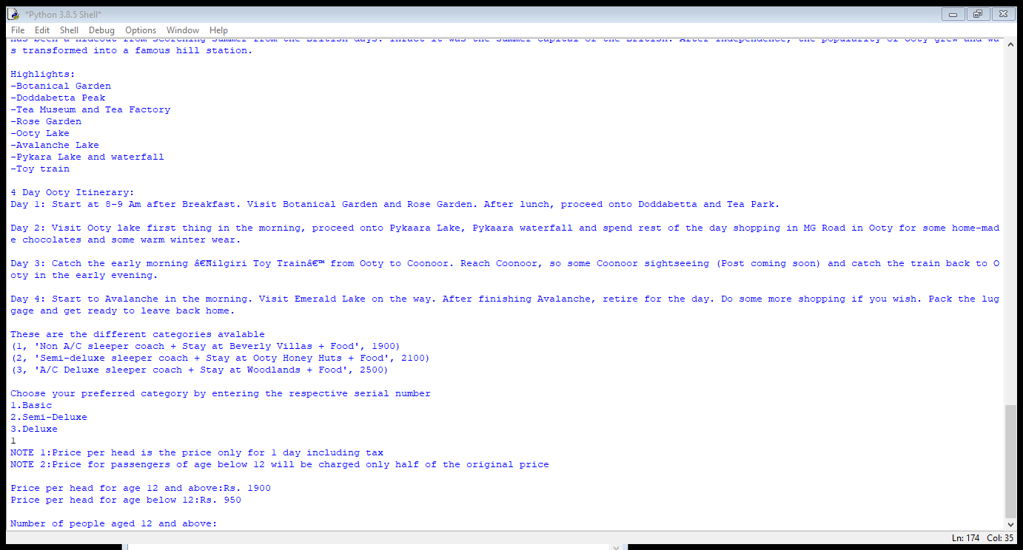

Fig 5.1: Different categories for the tour available

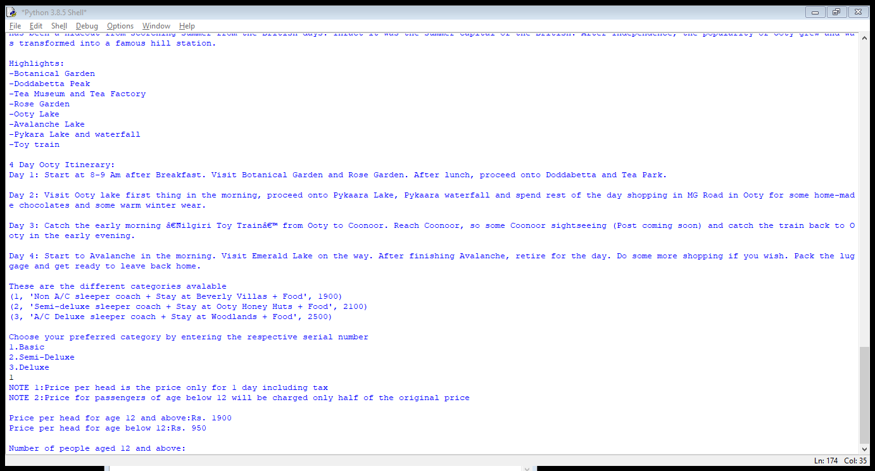

Fig 5.2: User’s choice of category



Fig 6: Extra details about the price

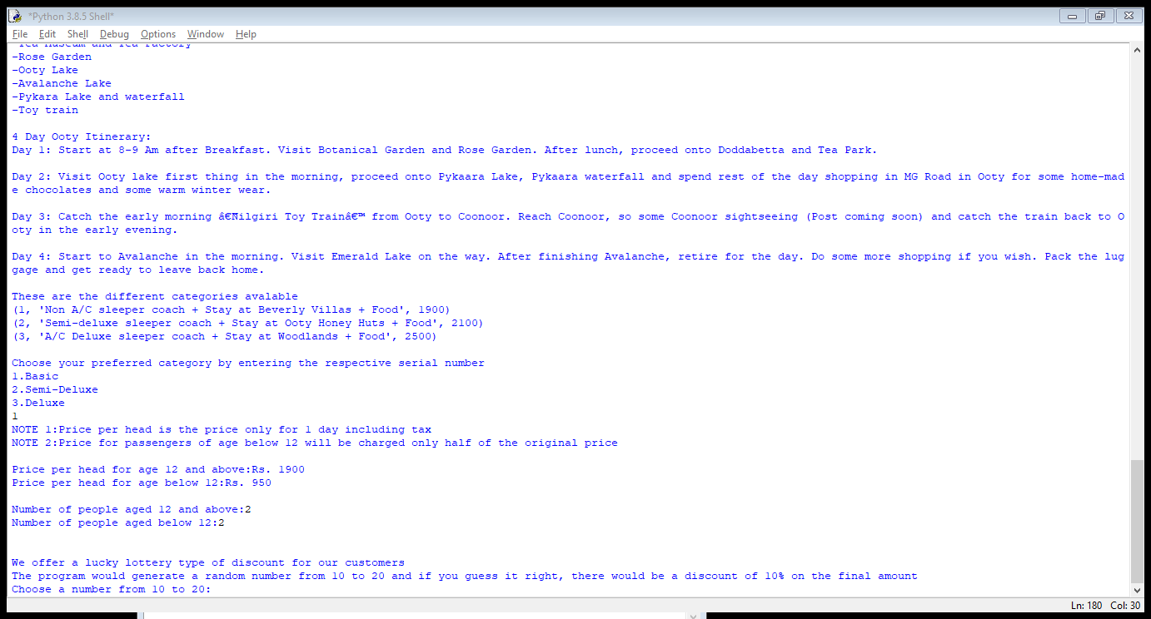

Fig 7: Inputting the number of people for each age category

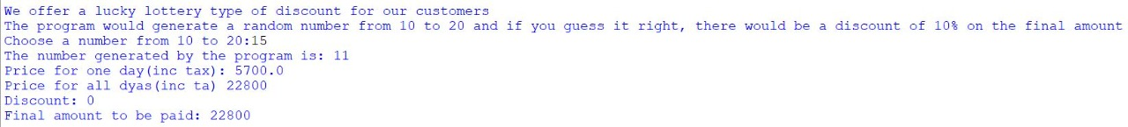

Fig 8: Discount procedure and displaying final bill amount

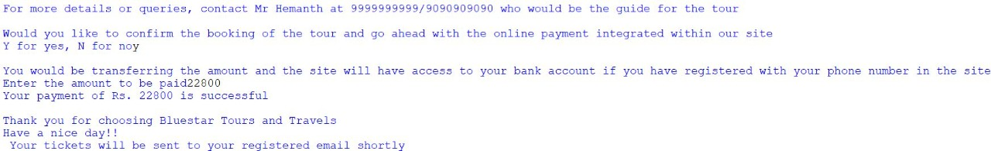

Fig 9: Payment procedure

**Conclusion and Future enhancements**

* Personal info of the user and be saved for future reference. This will prevent the user from having to log in many times.
* More Destinations and travel methods will be added.
* Update in average visitor graph
* Video files about the destinations can be uploaded
* Different modes of payments can be introduced

**References**

Textbook referred: Introduction to Computer Science Using Python: A Computational Problem Solving Focus, by Charles Dierbach, Wiley India Edition, John Wiley, 2015​​​​​​​.

[www.edureka.com](http://www.edureka.com)

[www.stackoverflow.com](http://www.stackoverflow.com)

[www.educative.io](http://www.educative.io)

[www.tourism-of-india.com](http://www.tourism-of-india.com)